# ***Curriculum Vitae***

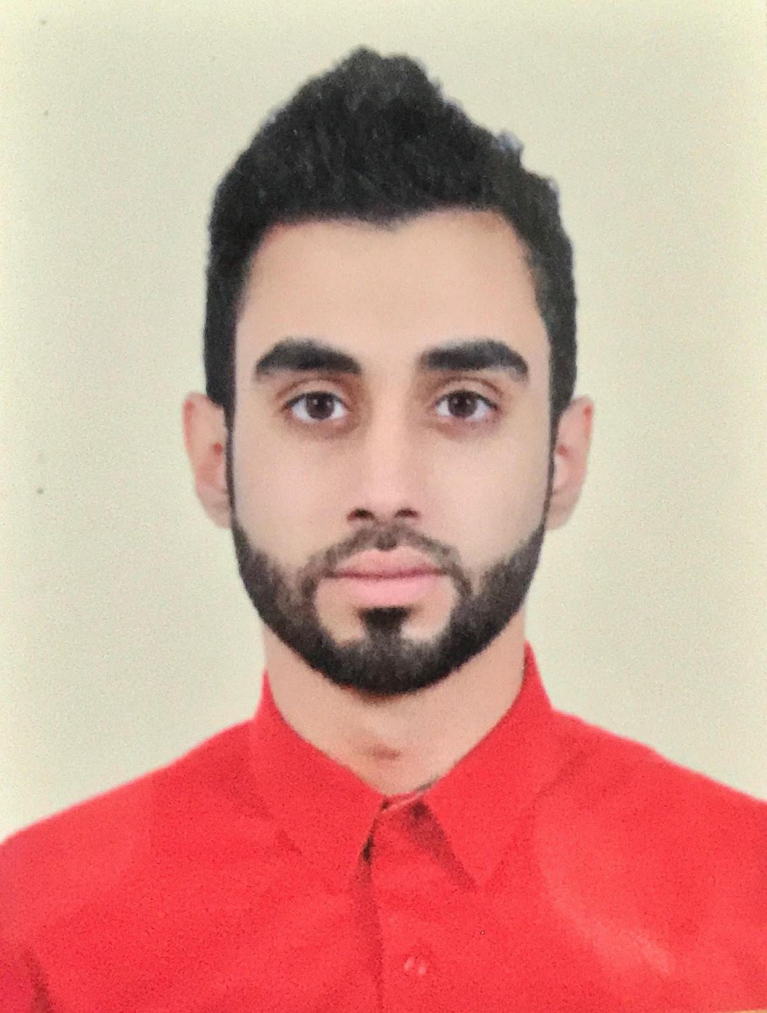

|  |  |  |  |  |  |  |
| --- | --- | --- | --- | --- | --- | --- |
| Osama Al-Jamal Email icon Oj2655@gmail.com Telephone icon +973 66988224  |  | | --- | | Objective Line graphic  Hard working individual looking to improve my work experience as well as my own skills. | | Skills Line graphic   * Reliable, Confident and Punctual. * Fluent in both written and spoken English. * Able to resolve conflict. * Ability to work under constant pressure. * Quick learner. * Enthusiastic about working. * Excellent Customer Service * Friendly attitude | | |  | | --- | | ExperienceDirect Sales Representative - OSNDecember 2017 – December 2018 -Achieved Monthly Targets Every Month  -Won Regional Competitions in Sales Achievement  -Followed Up With Potential Sales Clients.  -Achieved Remarkable Sales Revenue Customer Service representative – Zain BahrainFebruary 2017 – November 2017 -Enrolled in Zain Bahrain F.U.N Program and passed all the tests.  -Worked as a Customer Service Agents, As well as a Call Center Agent.  -Handled Customer Complaints and Inquires.  -Used Sales Techniques to Achieve Targets, such as Upselling/Cross Selling. | | Educationhighschool dimploma – jun 2016Hamad Town Secondary School -Commercial Studies.  -GPA of 89.6 BA in Computer Science – sept 2016 – todayUniversity of Bahrain | |  | |